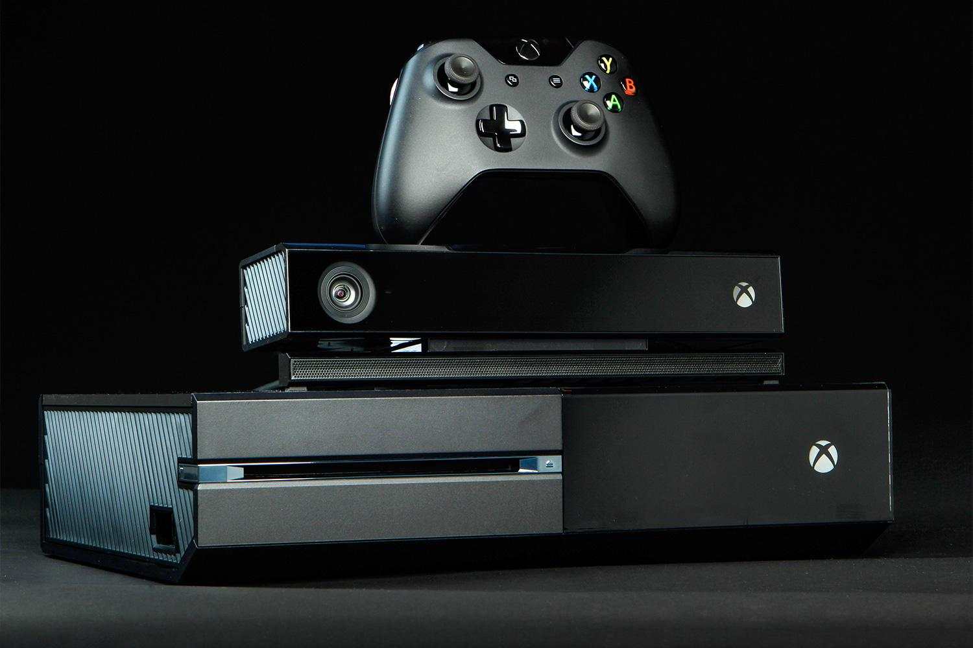

Figure introduction (box)

# Introduction to Microsoft and Xbox

The Microsoft Corporation, established in 1975 by Bill Gates and Paul Allen, has long been a leader in the technology sector and is well-known for its operating systems, productivity tools, and innovation. However, Microsoft decided to enter the game industry and unveiled the Xbox console in the early 2000s. The Xbox brand sought to provide engaging gaming experiences and forge a significant position in the console gaming market. (Britannica, 2021)

# People Involved in the Creation of Xbox and Its Operating System

## Seamus Blackley:

The development of the Xbox was greatly aided by Seamus Blackley, a brilliant game designer and developer. Blackley put together a group of competent engineers, designers, and software developers, combining their skills to create the console's initial design. Blackley's leadership and vision, combined with his love of gaming and dedication to creating ground-breaking experiences, lay the groundwork for the Xbox's success.



Figure Seamus Blackley (figure)

## Robbie Bach:

Robbie Bach had a key role in directing the creation and introduction of the Xbox as the former Chief Xbox Officer at Microsoft. Bach was a key contributor to the development of the Xbox brand because to his sharp strategic thinking and comprehensive knowledge of the video game sector. Under his leadership, Microsoft developed solid relationships with video game producers and developers, acquiring exclusive games and enhancing the Xbox catalogue.



Figure Robbie Bach (figure)

# Facts and Stats about Microsoft and Xbox

Xbox Launch: On November 15, 2001, the first Xbox was released in North America. As Microsoft competed against well-established players like Sony's PlayStation 2 and Nintendo's GameCube, the system's debut into the console gaming market was greeted with excitement and interest. The Xbox set itself apart because to its potent hardware, which offered outstanding visuals and computing capabilities. (Griffith, 2016)

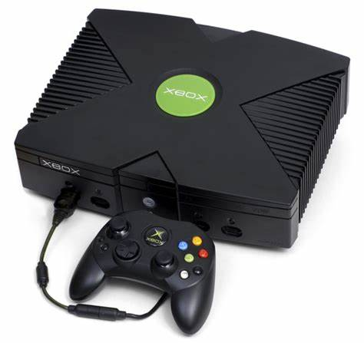

Figure xbox (figure)

Xbox Live: Microsoft's online gaming service, Xbox Live, is one of the distinguishing elements of the Xbox platform. Xbox Live, which was introduced in 2002, completely changed the way online multiplayer gaming was done. Players could connect with friends on Xbox Live, participate in multiplayer games, and have voice chats. Additionally, the service provided downloadable content (DLC) and game expansions for games.

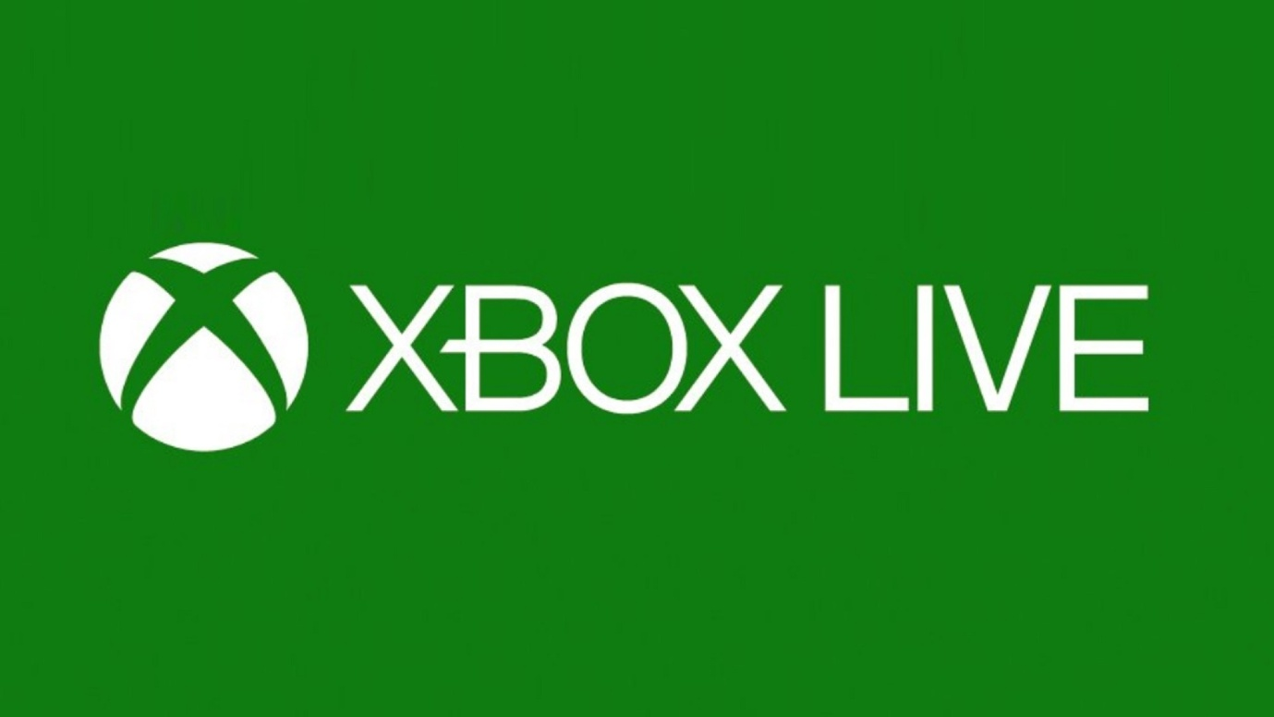

Figure live (figure)

Xbox 360: The Xbox 360, which was introduced on November 22, 2005, represents a substantial advancement in gaming technology. High-definition graphics, wireless controllers, and the Xbox Live Marketplace, a sizable online store, were all debuted with the device. The Xbox 360 overtook its rivals in terms of sales and popularity in the gaming industry because to its extensive game library and multimedia capabilities. (Ward, 2021)

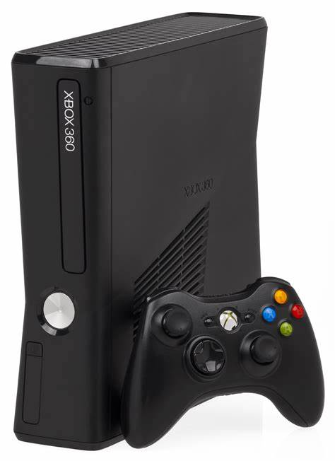

Figure 360 (figure)

Xbox One: On November 22, 2013, Microsoft launched the Xbox One, emphasising the integration of gaming, entertainment, and multimedia features. The console offered users the ability to fluidly transition between gaming and other forms of entertainment, as well as better visuals, cutting-edge social features, and a multimedia hub. The Kinect sensor gave the gaming experience a cutting-edge dimension by enabling voice commands and motion control. (Xbox, 2022)

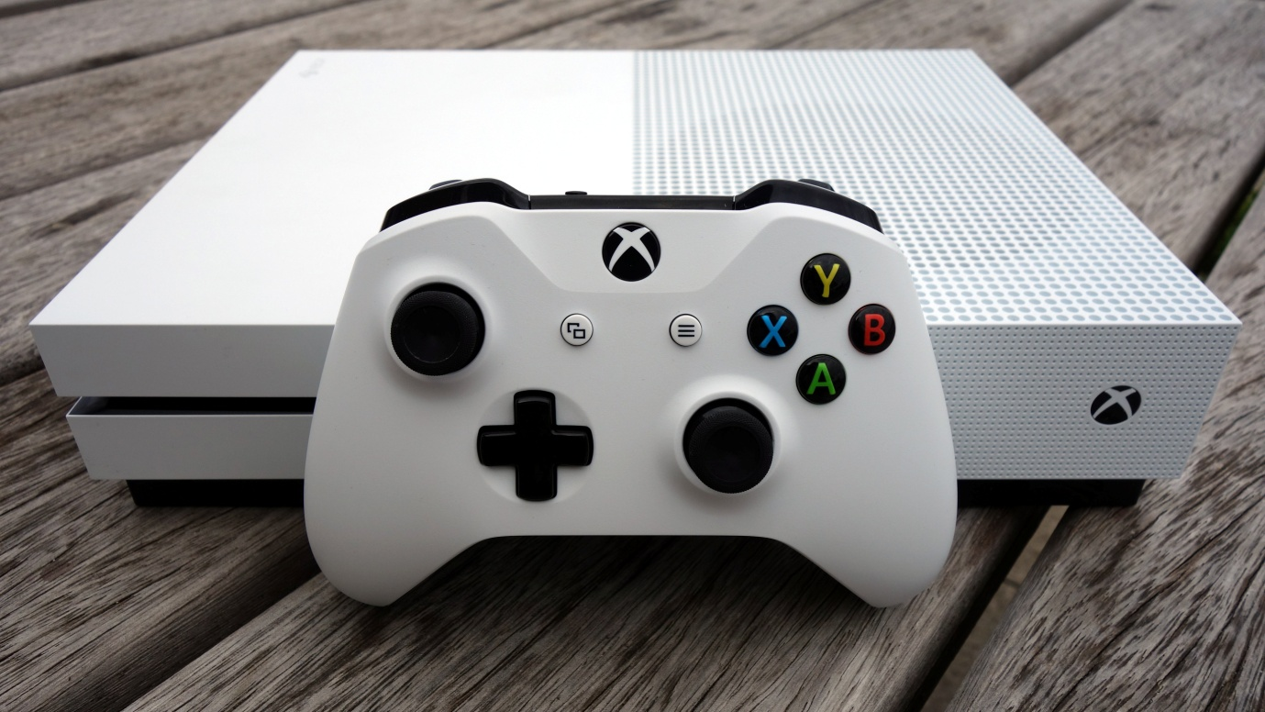

Figure xbox one (figure)

Xbox Game Pass: In 2017, Microsoft introduced Xbox Game Pass, a subscription-based service that grants players access to a vast library of games for a monthly fee. Xbox Game Pass offers a diverse collection of titles, including both first-party games developed by Microsoft Studios and third-party games from various publishers. The service has been highly praised for its value, providing gamers with the opportunity to explore a wide range of games without the need for individual purchases.

Xbox Series X and Series S: The Xbox Series X and Series S were introduced on November 10, 2020, and are the most recent additions to the Xbox portfolio. These consoles offer quicker load times, improved visuals with support for 4K gaming, and features like ray tracing, which represent a major improvement in hardware capabilities.

The Xbox Series S offers a more economical choice with slightly lower capabilities, while the Xbox Series X is positioned as the flagship model and offers the best gaming experience.

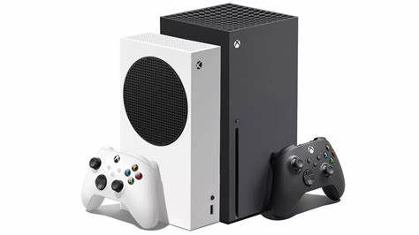

Figure series (figure)

Partnerships and Acquisitions: By forming partnerships and making acquisitions, Microsoft has systematically increased its game portfolio. Minecraft's very successful developers, Mojang Studios, were purchased by Microsoft in 2014. In addition to bringing one of the most popular game titles under the Xbox brand, this acquisition made it possible to play across platforms and integrate with other Microsoft services. Additionally, Microsoft has partnered with game publishers and developers to get exclusive titles and increase the Xbox's game library.

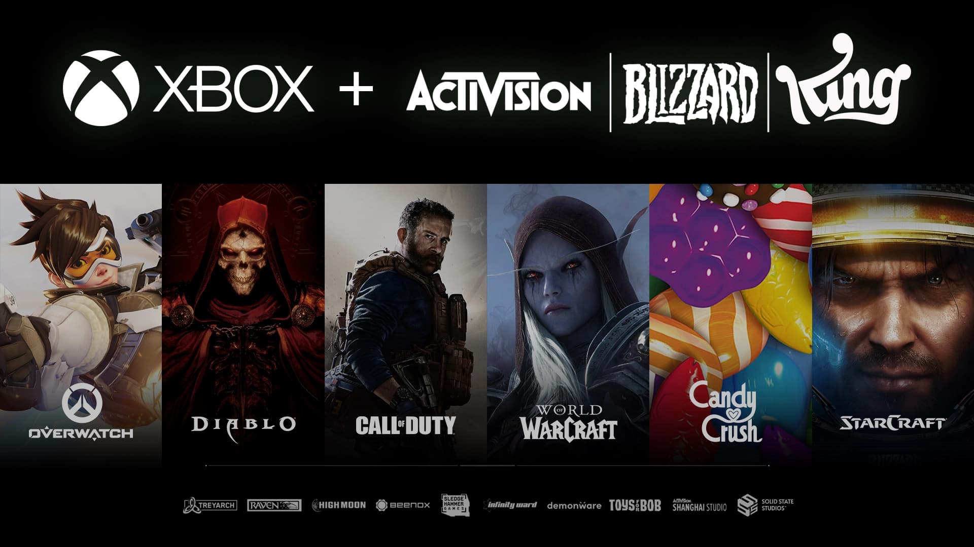

Figure (figure)

Selected Device:  
Among the various x box consoles, we have selected the latest console i.e. X box series X. The Xbox Series X, developed by Microsoft, is a cutting-edge gaming console that represents a significant leap in technology and innovation within the gaming industry. Released in November 2020, the Xbox Series X is the flagship model of the ninth generation of video game consoles, following the Xbox One. With its advanced hardware, enhanced software capabilities, and immersive gaming experiences, the Xbox Series X has garnered attention not only from gamers but also from technology enthusiasts and industry experts.

# Bibliography

Britannica, T. E. (2021, january 15). *The Editors of Encyclopaedia Britannica*. Retrieved from https://www.britannica.com/technology/Xbox.

Griffith, E. (2016). *The Story Behind the Xbox*. Retrieved from https://www.pcmag.com/news/the-story-behind-the-xbox.

https://www.britannica.com/editor/The-Editors-of-Encyclopaedia-Britannica/4419. (2023, july 19). Xbox.

Ward, L. (2021, april 7). *Facts About Xbox 360*. Retrieved from https://www.thefactsite.com/facts-about-xbox-360/.

Xbox. (2022). *Xbox*. Retrieved from https://www.windowscentral.com/gaming/xbox.